**PREDICTION IMDB SCORES**

**project title:** predicted for IMDb scores

**phase 3**: Development

**part 1:**

**Data Preprocessing:**

* Data preprocessing is a crucial step within the statistics analysis and gadget gaining knowledge of pipeline.
* It includes a sequence of strategies and operations finished on uncooked statistics to clean, organize, and transform it right into a layout that is suitable for analysis or device mastering version schooling.
* Data preprocessing goals to enhance the first-class of the records, making it greater reliable and conducive to generating accurate consequences.

Here are some common tasks and techniques involved in data preprocessing:

**Data Cleaning:**

* Handling missing values: Deciding how to deal with missing data, whether by imputing values or removing incomplete records.
* Outlier detection and treatment: Identifying and handling data points that significantly deviate from the norm.

**Noise reduction:**

* Smoothing noisy data through techniques like filtering.

**Data Transformation:**

* **Data normalization:** Scaling numerical features to a standard range (e.g., between 0 and 1) to ensure that they have similar influence in the analysis.
* **Encoding categorical variables:** Converting categorical data into numerical format, such as one-hot encoding or label encoding.
* **Feature engineering:** Creating new features or modifying existing ones to capture more meaningful information from the data.
* **Dimensionality reduction:** Reducing the number of features while retaining essential information, using methods like Principal Component Analysis (PCA).

**Data Integration:**

* **Merging or joining datasets:** Combining data from multiple sources into a single dataset for analysis.

**Aggregation:** Summarizing data at a higher level of granularity, such as aggregating daily sales into monthly totals.

**Data Reduction:**

* **Sampling:** Reducing the size of a large dataset by randomly selecting a representative subset.
* **Binning:** Grouping continuous data into discrete bins to simplify analysis.
* **Filtering:** Selecting a subset of data based on specific criteria.

**Data Standardization:**

* Ensuring that data follows a consistent format and structure.
* Date and time format conversion: Converting date and time data into a uniform format.
* Currency conversion: Converting monetary values into a common currency.

**Data Scaling:**

* Scaling numerical data to a common range to prevent some features from dominating the analysis.

Data preprocessing is an iterative process that may involve several of these steps in various orders, depending on the specific dataset and the analysis goals. Proper data preprocessing is essential for improving the accuracy and effectiveness of machine learning models, as well as for making data more accessible for traditional statistical analysis.

Here is the data preprocessing codes along with the output of the given dataset:

**Importing the libraries:**

Import three basic libraries which are very common in machine learning and will be used every time you train a model

* **NumPy:** it is a library that allows us to work with arrays and as most machine learning models work on arrays NumPy makes it easier
* **matplotlib:** this library helps in plotting graphs and charts, which are very useful while showing the result of your model
* **Pandas:** pandas allowsus to import our dataset and also creates a matrix of features containing the dependent and independent variable.

**Code:**

*#Import libraries*

import numPy as np

import pandas as pd

import matplotlib.pyplo

t as plot

import seaborn as sns

from plotnine import *

**1.1 Background**

This dataset contains the information about the movies . For a movie to be commercial success , it depends on various factors like director, actors ,critic reviews and viewers reaction. Imdb score is one of the important factor to measure the movie's success.

**1.2 Description of dataset attributes**

Please find the details for the datset attributes:-

1. Color :- Movie is black or coloured
2. Director_name:- Name of the movie director
3. num_critic_for_reviews :- No of critics for the movie
4. duration:- movie duration in minutes
5. director_facebook_likes:-Number of likes for the Director on his Facebook Page
6. actor_3_facebook_likes:- No of likes for the actor 3 on his/her facebook Page
7. actor2_name:- name of the actor 2
8. actor_1_facebook_likes:- No of likes for the actor 1 on his/her facebook Page
9. gross:- Gross earnings of the movie in Dollars
10. genres:- Film categorization like ‘Animation’, ‘Comedy’, ‘Romance’, ‘Horror’, ‘Sci-Fi’, ‘Action’, ‘Family’
11. actor_1_name:- Name of the actor 1
12. movie_title:-Title of the movie
13. num_voted_users:-No of people who voted for the movie
14. cast_total_facebook_likes:- Total facebook like for the movie
15. actor_3_name:- Name of the actor 3
16. facenumber_in_poster:- No of actors who featured in the movie poster
17. plot_keywords:-Keywords describing the movie plots
18. movie_imdb_link:-Link of the movie link
19. num_user_for_reviews:- Number of users who gave a review
20. language:- Language of the movie
21. country:- Country where movie is produced
22. content_rating:- Content rating of the movie
23. budget:- Budget of the movie in Dollars
24. title_year:- The year in which the movie is released
25. actor_2_facebook_likes:- facebook likes for the actor 2
26. imdb_score:- IMDB score of the movie
27. aspect_ratio :- Aspect ratio the movie was made in
28. movie_facebook_likes:- Total no of facebook likes for the movie
29. **1.3 Case Study**
30. The dataset here gives the massive information about the movies and their IMDB scores respectively. We are going to analyze each and every factors which can influence the imdb ratings so that we can predict better results.The movie with the higher imdb score is more successful as compared to the movies with low imdb score
31. 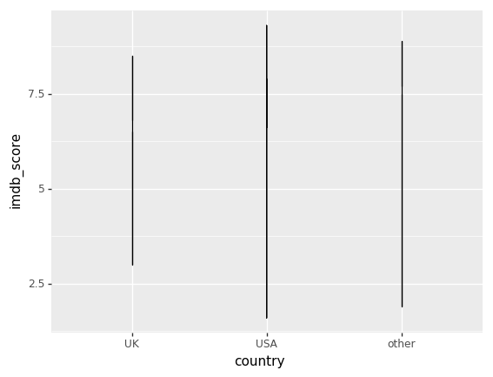

**2. Data Preprocessing**

*#Reading the Data*

movie_df=pd.read_csv("/kaggle/input/imdb-5000-movie-dataset/movie_metadata.csv")

*#Displaying the first 10 records*

movie_df.head(10)

*#Shape of the dataset (no of rows and no of columns)*

movie_df.shape

Out[4]:

(5043, 28)

*#Displaying the data type of the dataset attributes*

movie_df.dtypes

Out[5]:

color object

director_name object

num_critic_for_reviews float64

duration float64

director_facebook_likes float64

actor_3_facebook_likes float64

actor_2_name object

actor_1_facebook_likes float64

gross float64

genres object

actor_1_name object

movie_title object

num_voted_users int64

cast_total_facebook_likes int64

actor_3_name object

facenumber_in_poster float64

plot_keywords object

movie_imdb_link object

num_user_for_reviews float64

language object

country object

content_rating object

budget float64

title_year float64

actor_2_facebook_likes float64

imdb_score float64

aspect_ratio float64

movie_facebook_likes int64

dtype: object

**We can say we have the datset divided into categorical and numeric columns "

**Categorical Columns**

Color,Director name, actor name,genres,movie_title,language,country,content_rating.

**Numerical Columns**

num_critic_for_reviews,duration,director_facebook_likes ,actor_3_facebook_likes,actor_1_facebook_likes ,gross,num_voted_users,cast_total_facebook_likes,facenumber_in_poster,num_user_for_reviews ,budget,title_year, actor_2_facebook_likes ,imdb_score,aspect_ratio,movie_facebook_like

Index(['director_name', 'num_critic_for_reviews', 'duration',

'director_facebook_likes', 'actor_3_facebook_likes', 'actor_2_name',

'actor_1_facebook_likes', 'gross', 'genres', 'actor_1_name',

'movie_title', 'num_voted_users', 'cast_total_facebook_likes',

'actor_3_name', 'facenumber_in_poster', 'plot_keywords',

'num_user_for_reviews', 'language', 'country', 'content_rating',

'budget', 'title_year', 'actor_2_facebook_likes', 'imdb_score',

'aspect_ratio', 'movie_facebook_likes'],

dtype='object')

director_name True

num_critic_for_reviews True

duration True

director_facebook_likes True

actor_3_facebook_likes True

actor_2_name True

actor_1_facebook_likes True

gross True

genres False

actor_1_name True

movie_title False

num_voted_users False

cast_total_facebook_likes False

actor_3_name True

facenumber_in_poster True

plot_keywords True

num_user_for_reviews True

language True

country True

content_rating True

budget True

title_year True

actor_2_facebook_likes True

imdb_score False

aspect_ratio True

movie_facebook_likes False

dtype: bool

movie_df.isna().sum()

director_name 104

num_critic_for_reviews 50

duration 15

director_facebook_likes 104

actor_3_facebook_likes 23

actor_2_name 13

actor_1_facebook_likes 7

gross 884

genres 0

actor_1_name 7

movie_title 0

num_voted_users 0

cast_total_facebook_likes 0

actor_3_name 23

facenumber_in_poster 13

plot_keywords 153

num_user_for_reviews 21

language 12

country 5

content_rating 303

budget 492

title_year 108

actor_2_facebook_likes 13

imdb_score 0

aspect_ratio 329

movie_facebook_likes 0

dtype: int64

movie_df.dropna(axis=0,subset=['director_name', 'num_critic_for_reviews','duration','director_facebook_likes','actor_3_facebook_likes','actor_2_name','actor_1_facebook_likes','actor_1_name','actor_3_name','facenumber_in_poster','num_user_for_reviews','language','country','actor_2_facebook_likes','plot_keywords'],inplace=True)

movie_df.shape

(4737, 26)

**We lost only 6% of the data which is acceptable**

*#Replacing the content rating with Value R as it has highest frequency*

movie_df["content_rating"].fillna("R", inplace = True)

In [15]:

*#Replacing the aspect_ratio with the median of the value as the graph is right skewed*

movie_df["aspect_ratio"].fillna(movie_df["aspect_ratio"].median(),inplace=True)

In [16]:

linkcode

*#We need to replace the value in budget with the median of the value*

movie_df["budget"].fillna(movie_df["budget"].median(),inplace=True)

*# We need to replace the value in gross with the median of the value*

movie_df['gross'].fillna(movie_df['gross'].median(),inplace=True)

In [18]:

*# Recheck that all the null values are removed*

movie_df.isna().sum()

Out[18]:

director_name 0

num_critic_for_reviews 0

director_facebook_likes 0

actor_3_facebook_likes 0

actor_2_name 0

actor_1_facebook_likes 0

gross 0

genres 0

actor_1_name 0

movie_title 0

num_voted_users 0

cast_total_facebook_likes 0

actor_3_name 0

facenumber_in_poster 0

plot_keywords 0

num_user_for_reviews 0

language 0

country 0

content_rating 0

budget 0

title_year 0

actor_2_facebook_likes 0

imdb_score 0

aspect_ratio 0

movie_facebook_likes 0

dtype: int64

*#Removing the duplicate values in the datset*

movie_df.drop_duplicates(inplace=True)

movie_df.shape

*Count of the language values*

movie_df["language"].value_counts()

English 4405

French 69

Spanish 35

Hindi 25

Mandarin 24

German 18

Japanese 16

Russian 11

Italian 10

Cantonese 10

Portuguese 8

Korean 8

Danish 5

Norwegian 4

Swedish 4

Hebrew 4

Dutch 4

Persian 4

Arabic 3

Thai 3

Indonesian 2

None 2

Aboriginal 2

Dari 2

Zulu 2

Hungarian 1

Mongolian 1

Greek 1

Romanian 1

Bosnian 1

Telugu 1

Maya 1

Polish 1

Filipino 1

Czech 1

Dzongkha 1

Kazakh 1

Vietnamese 1

Icelandic 1

Aramaic 1

Name: language, dtype: int64

*# Graphical presentaion*

plt.figure(figsize=(40,10))

sns.countplot(movie_df["language"])

plt.show()

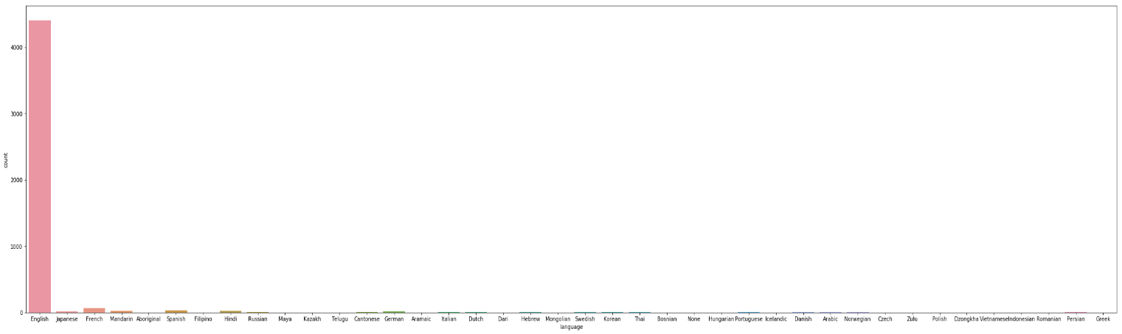

*#Most of the values for the languages is english we can drop the english column*

movie_df.drop('language',axis=1,inplace=True)

In [23]:

linkcode

*#Creating a new column to check the net profit made by the company (Gross-Budget)*

movie_df["Profit"]=movie_df['budget'].sub(movie_df['gross'], axis = 0)

value_counts=movie_df["country"].value_counts()

print(value_counts)

USA 3568

UK 420

France 149

Canada 107

Germany 96

Australia 53

Spain 32

India 27

China 24

Japan 21

Italy 20

Hong Kong 16

New Zealand 14

South Korea 12

Ireland 11

Denmark 11

Russia 11

Mexico 11

South Africa 8

Brazil 8

Norway 7

Netherlands 5

Sweden 5

Thailand 4

Iran 4

Argentina 4

Czech Republic 3

Switzerland 3

Belgium 3

Israel 3

West Germany 3

Poland 2

Taiwan 2

Iceland 2

Romania 2

Hungary 2

Greece 2

Soviet Union 1

Slovakia 1

Finland 1

Official site 1

Turkey 1

Peru 1

Libya 1

Afghanistan 1

Cambodia 1

Indonesia 1

Nigeria 1

Kyrgyzstan 1

Colombia 1

New Line 1

Philippines 1

Bahamas 1

Bulgaria 1

Georgia 1

Aruba 1

Chile 1

Name: country, dtype: int64

**We can see most of the movies are from USA ,UK and the rest of the countries**

In [26]:

*##get top 2 values of index*

*##get top 2 values of index*

vals = value_counts[:2].index

print (vals)

movie_df['country'] = movie_df.country.where(movie_df.country.isin(vals), 'other')

Index(['USA', 'UK'], dtype='object')

In [27]:

*#Successfully divided the country into three catogories*

movie_df["country"].value_counts()

Out[27]:

USA 3568

other 707

UK 420

Name: country, dtype: int64

In [28]:

linkcode

movie_df.head(10)

/opt/conda/lib/python3.6/site-packages/plotnine/coords/coord_cartesian.py:31: MatplotlibDeprecationWarning: The Bunch class was deprecated in Matplotlib 3.0 and will be removed in 3.2. Use types.SimpleNamespace instead.

self.limits = Bunch(xlim=xlim, ylim=ylim)

/opt/conda/lib/python3.6/copy.py:274: MatplotlibDeprecationWarning: The Bunch class was deprecated in Matplotlib 3.0 and will be removed in 3.2. Use types.SimpleNamespace instead.

y = func(*args)

/opt/conda/lib/python3.6/site-packages/plotnine/facets/facet.py:151: MatplotlibDeprecationWarning: The Bunch class was deprecated in Matplotlib 3.0 and will be removed in 3.2. Use types.SimpleNamespace instead.

scales = Bunch()

/opt/conda/lib/python3.6/site-packages/plotnine/facets/layout.py:147: MatplotlibDeprecationWarning: The Bunch class was deprecated in Matplotlib 3.0 and will be removed in 3.2. Use types.SimpleNamespace instead.

return Bunch(x=xsc, y=ysc)

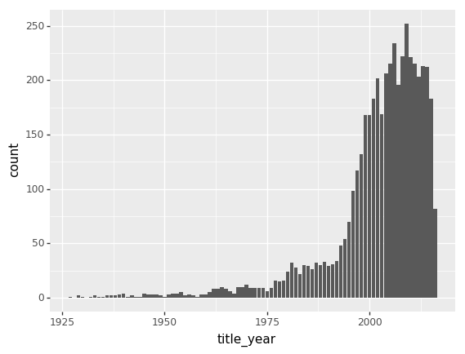

*#Relationship between the imdb score and the profit made by the movie*

ggplot(aes(x='imdb_score', y='Profit'), data=movie_df) +\

geom_line() +\

stat_smooth(colour='blue', span=1)

/opt/conda/lib/python3.6/site-packages/plotnine/coords/coord_cartesian.py:31: MatplotlibDeprecationWarning: The Bunch class was deprecated in Matplotlib 3.0 and will be removed in 3.2. Use types.SimpleNamespace instead.

self.limits = Bunch(xlim=xlim, ylim=ylim)

/opt/conda/lib/python3.6/copy.py:274: MatplotlibDeprecationWarning: The Bunch class was deprecated in Matplotlib 3.0 and will be removed in 3.2. Use types.SimpleNamespace instead.

y = func(*args)

/opt/conda/lib/python3.6/site-packages/plotnine/facets/facet.py:151: MatplotlibDeprecationWarning: The Bunch class was deprecated in Matplotlib 3.0 and will be removed in 3.2. Use types.SimpleNamespace instead.

scales = Bunch()

/opt/conda/lib/python3.6/site-packages/plotnine/facets/layout.py:147: MatplotlibDeprecationWarning: The Bunch class was deprecated in Matplotlib 3.0 and will be removed in 3.2. Use types.SimpleNamespace instead.

return Bunch(x=xsc, y=ysc)

/opt/conda/lib/python3.6/site-packages/numpy/core/fromnumeric.py:2389: FutureWarning: Method .ptp is deprecated and will be removed in a future version. Use numpy.ptp instead.

return ptp(axis=axis, out=out, **kwargs)

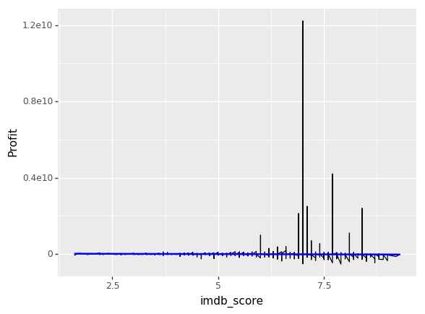

*#Finding the corelation between imdb_rating with respect to no of facebook likes*

(ggplot(movie_df)

+ aes(x='imdb_score', y='movie_facebook_likes')

+ geom_line()

+ labs(title='IMDB_Score vs. Facebook like for Movies', x='IMDB scores', y='Facebook Likes for movies')

)

/opt/conda/lib/python3.6/site-packages/plotnine/coords/coord_cartesian.py:31: MatplotlibDeprecationWarning: The Bunch class was deprecated in Matplotlib 3.0 and will be removed in 3.2. Use types.SimpleNamespace instead.

self.limits = Bunch(xlim=xlim, ylim=ylim)

/opt/conda/lib/python3.6/copy.py:274: MatplotlibDeprecationWarning: The Bunch class was deprecated in Matplotlib 3.0 and will be removed in 3.2. Use types.SimpleNamespace instead.

y = func(*args)

/opt/conda/lib/python3.6/site-packages/plotnine/facets/facet.py:151: MatplotlibDeprecationWarning: The Bunch class was deprecated in Matplotlib 3.0 and will be removed in 3.2. Use types.SimpleNamespace instead.

scales = Bunch()

/opt/conda/lib/python3.6/site-packages/plotnine/facets/layout.py:147: MatplotlibDeprecationWarning: The Bunch class was deprecated in Matplotlib 3.0 and will be removed in 3.2. Use types.SimpleNamespace instead.

return Bunch(x=xsc, y=ysc)



*#Top 20 movies based on the profit they made*

plt.figure(figsize=(10,8))

movie_df= movie_df.sort_values(by ='Profit' , ascending=False)

movie_df_new=movie_df.head(20)

ax=sns.pointplot(movie_df_new['Profit'], movie_df_new['budget'], hue=movie_df_new['movie_title'])

ax.set_xticklabels(ax.get_xticklabels(), rotation=40, ha="right")

plt.tight_layout()

plt.show()

*#Top 20 movies based on the profit they made*

plt.figure(figsize=(10,8))

movie_df= movie_df.sort_values(by ='Profit' , ascending=False)

movie_df_new=movie_df.head(20)

ax=sns.pointplot(movie_df_new['Profit'], movie_df_new['budget'], hue=movie_df_new['movie_title'])

ax.set_xticklabels(ax.get_xticklabels(), rotation=40, ha="right")

plt.tight_layout()

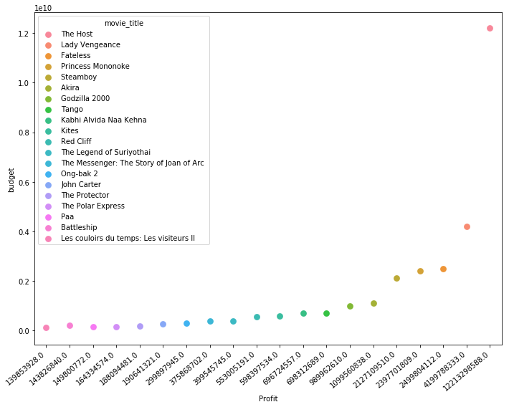

*# Top 20 movies based on the profit percentage*

plt.figure(figsize=(10,8))

movie_df= movie_df.sort_values(by ='Profit_Percentage' , ascending=False)

movie_df_new=movie_df.head(20)

ax=sns.pointplot(movie_df_new['Profit_Percentage'], movie_df_new['budget'], hue=movie_df_new['movie_title'])

ax.set_xticklabels(ax.get_xticklabels(), rotation=40, ha="right")

plt.tight_layout()

plt.show()

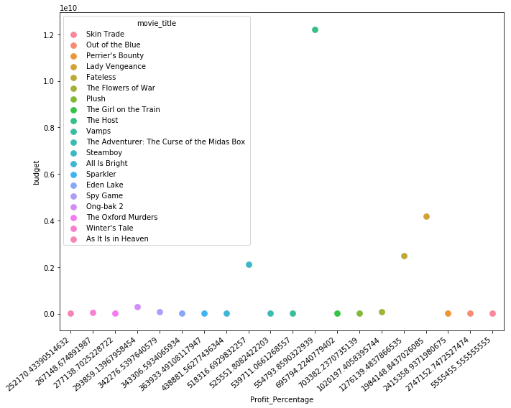

*#Top 20 directors based on the IMDB ratings*

plt.figure(figsize=(10,8))

movie_df= movie_df.sort_values(by ='imdb_score' , ascending=False)

movie_df_new=movie_df.head(20)

ax=sns.pointplot(movie_df_new['director_name'], movie_df_new['imdb_score'], hue=movie_df_new['movie_title'])

ax.set_xticklabels(ax.get_xticklabels(), rotation=40, ha="right")

plt.tight_layout()

plt.show()

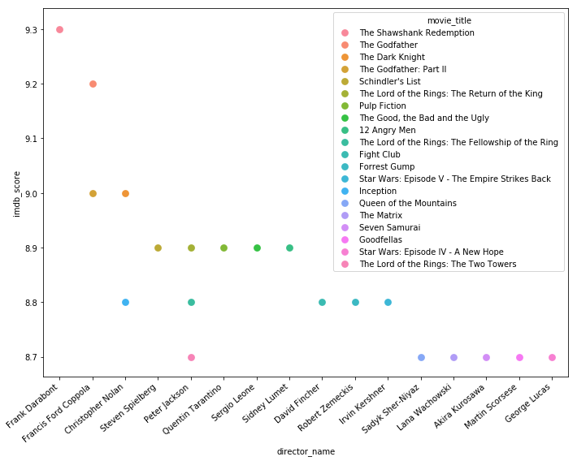

*#Commercial success vs critial acclaim*

movie_df= movie_df.sort_values(by ='Profit_Percentage' , ascending=False)

movie_df_new=movie_df.head(20)

(ggplot(movie_df_new)

+ aes(x='imdb_score', y='gross',color = "content_rating")

+ geom_point()

+ geom_hline(aes(yintercept = 600)) +

geom_vline(aes(xintercept = 10)) +

xlab("Imdb score") +

ylab("Gross money earned in million dollars") +

ggtitle("Commercial success Vs Critical acclaim") +

annotate("text", x = 8.5, y = 700, label = "High ratings **\n** & High gross"))

/opt/conda/lib/python3.6/site-packages/plotnine/coords/coord_cartesian.py:31: Mat

/opt/conda/lib/python3.6/site-packages/plotnine/coords/coord_cartesian.py:31: MatplotlibDeprecationWarning: The Bunch class was deprecated in Matplotlib 3.0 and will be removed in 3.2. Use types.SimpleNamespace instead.

self.limits = Bunch(xlim=xlim, ylim=ylim)

/opt/conda/lib/python3.6/copy.py:274: MatplotlibDeprecationWarning: The Bunch class was deprecated in Matplotlib 3.0 and will be removed in 3.2. Use types.SimpleNamespace instead.

y = func(*args)

/opt/conda/lib/python3.6/site-packages/plotnine/layer.py:520: MatplotlibDeprecationWarning: isinstance(..., numbers.Number)

return not cbook.iterable(value) and (cbook.is_numlike(value) or

/opt/conda/lib/python3.6/site-packages/plotnine/facets/facet.py:151: MatplotlibDeprecationWarning: The Bunch class was deprecated in Matplotlib 3.0 and will be removed in 3.2. Use types.SimpleNamespace instead.

scales = Bunch()

/opt/conda/lib/python3.6/site-packages/plotnine/facets/layout.py:147: MatplotlibDeprecationWarning: The Bunch class was deprecated in Matplotlib 3.0 and will be removed in 3.2. Use types.SimpleNamespace instead.

return Bunch(x=xsc, y=ysc)

/opt/conda/lib/python3.6/site-packages/plotnine/coords/coord.py:144: MatplotlibDeprecationWarning: The Bunch class was deprecated in Matplotlib 3.0 and will be removed in 3.2. Use types.SimpleNamespace instead.

y=panel_params['y_range'])

/opt/conda/lib/python3.6/site-packages/plotnine/guides/guide_legend.py:179: MatplotlibDeprecationWarning: The Bunch class was deprecated in Matplotlib 3.0 and will be removed in 3.2. Use types.SimpleNamespace instead.

self.glayers.append(Bunch(geom=geom, data=data, layer=l))

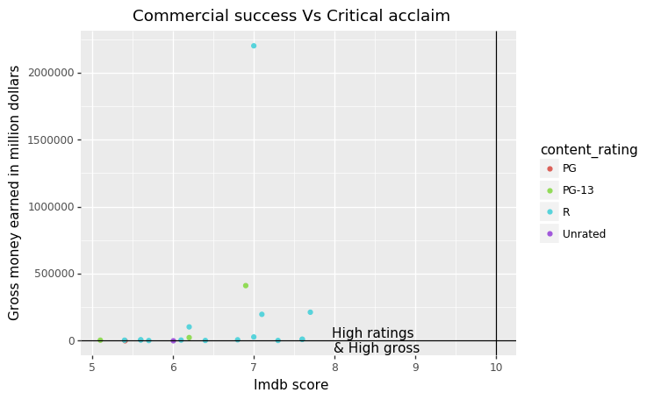

*Top 20 actors of movies based on the commerical success*

plt.figure(figsize=(10,8))

movie_df= movie_df.sort_values(by ='Profit_Percentage' , ascending=False)

movie_df_new=movie_df.head(20)

ax=sns.pointplot(movie_df_new['actor_1_name'], movie_df_new['Profit_Percentage'], hue=movie_df_new['movie_title'])

ax.set_xticklabels(ax.get_xticklabels(), rotation=40, ha="right")

plt.tight_layout()

plt.show()

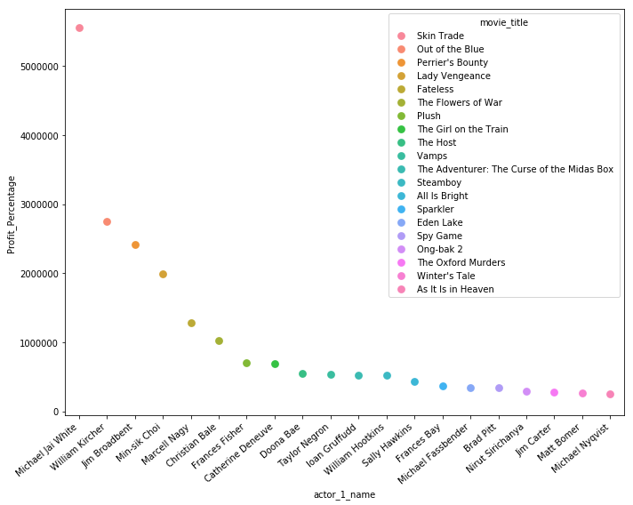

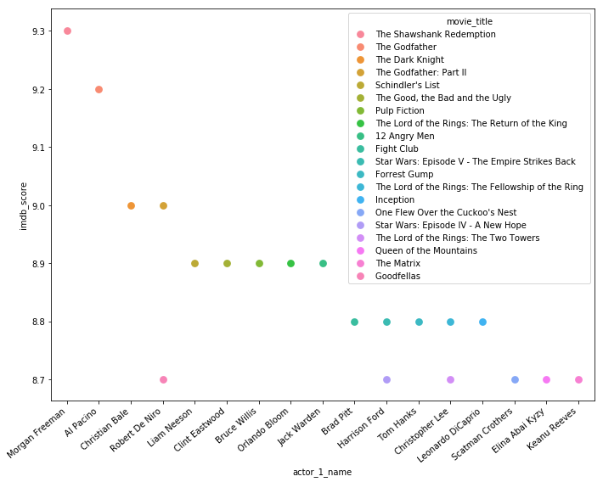

*# Correlation with heat map*

import matplotli.pyplot as plot

import seaborn as sns

corr = movie_df.corr()

sns.set_context("notebook", font_scale=1.0, rc={"lines.linewidth": 2.5})

plt.figure(figsize=(13,7))

*# create a mask so we only see the correlation values once*

mask = np.zeros_like(corr)

mask[np.triu_indices_from(mask, 1)] = True

a = sns.heatmap(corr,mask=mask, annot=True, fmt='.2f')

rotx = a.set_xticklabels(a.get_xticklabels(), rotation=90)

roty = a.set_yticklabels(a.get_yticklabels(), rotation=30)

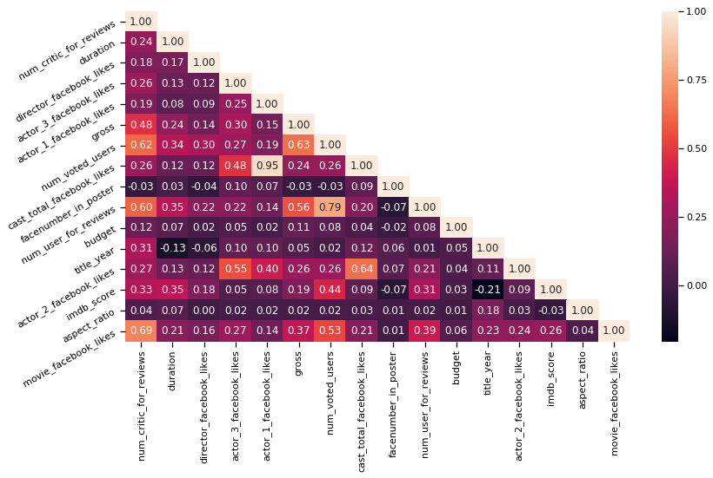

We can see that the cast_total_facebook_likes and actor_1_facebook_like are highly correlated to each other. Both actor2 and actor3 are also somehow correlated to the total. So we want to modify them into two variables: actor_1_facebook_likes and other_actors_facebook_likes.

There are high correlations among num_voted_users, num_user_for_reviews and num_critic_for_reviews. We want to keep num_voted_users and take the ratio of num_user_for_reviews and num_critic_for_reviews.

*# New Correlation matrix shown in the figure*

import matplotlib.pyplot as plot

import seaborn as sns

corr = movie_df.corr()

sns.set_context("notebook", font_scale=1.0, arc={"lines.linewidth": 2.5})

plt.figure(figsize=(13,7))

*# create a mask so we only see the correlation values once*

mask = np.zeros_like(corr)

mask[np.triu_indices_from(mask, 1)] = True

a = sns.heatmap(corr,mask=mask, annot=True, fts='.2f')

rotx = a.set_xticklabels(a.get_xticklabels(), rotation=90)

roty = a.set_yticklabels(a.get_yticklabels(), rotation=30)

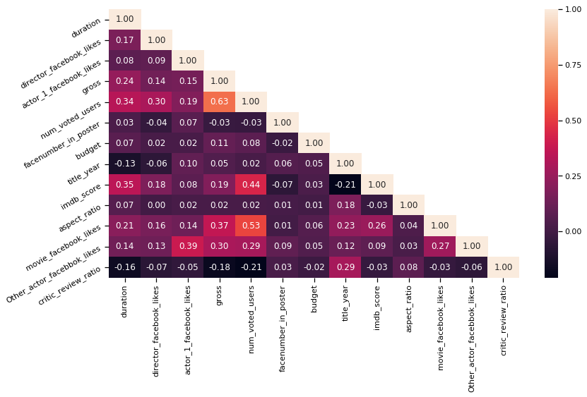

from sklearn.metrics import classification_report

print('Logistic Reports**\n**',classification_report(y_test, y_pred))

print('KNN Reports**\n**',classification_report(y_test, knnpred))

print('SVC Reports**\n**',classification_report(y_test, svcpred))

print('Naive BayesReports**\n**',classification_report(y_test, gaussiannbpred))

print('Decision Tree Reports**\n**',classification_report(y_test, dtreepred))

print('Ada Boosting**\n**',classification_report(y_test, abcl_pred))

print('Random Forests Reports**\n**',classification_report(y_test, rfcpred))

print('Bagging Clasifier',bgcl.oob_score_)

print('Gradient Boosting',classification_report(y_test, test_pred))

print('XGBoosting**\n**',classification_report(y_test, xgbprd))

logistic

Reports

precision recall f1-score support

1 0.00 0.00 0.00 46

2 0.50 0.25 0.33 378

3 0.72 0.92 0.81 924

4 0.84 0.52 0.65 61

accuracy 0.69 1409

macro avg 0.52 0.42 0.45 1409

weighted avg 0.64 0.69 0.65 1409

KNN Reports

precision recall f1-score support

1 0.00 0.00 0.00 46

2 0.46 0.41 0.44 378

3 0.73 0.83 0.78 924

4 1.00 0.20 0.33 61

accuracy 0.67 1409

macro avg 0.55 0.36 0.39 1409

weighted avg 0.64 0.67 0.64 1409

SVC Reports

precision recall f1-score support

1 0.14 0.02 0.04 46

2 0.42 0.42 0.42 378

3 0.74 0.79 0.76 924

4 0.57 0.33 0.42 61

accuracy 0.64 1409

macro avg 0.47 0.39 0.41 1409

weighted avg 0.62 0.64 0.63 1409

Naive BayesReports

precision recall f1-score support

1 0.05 0.91 0.09 46

2 0.50 0.00 0.01 378

3 0.71 0.01 0.01 924

4 0.11 0.85 0.19 61

accuracy 0.07 1409

macro avg 0.34 0.44 0.07 1409

weighted avg 0.61 0.07 0.02 1409

Decision Tree Reports

precision recall f1-score support

1 0.11 0.11 0.11 46

2 0.47 0.51 0.49 378

3 0.78 0.76 0.77 924

4 0.77 0.59 0.67 61

accuracy 0.67 1409

macro avg 0.53 0.49 0.51 1409

weighted avg 0.67 0.67 0.67 1409

Ada Boosting

precision recall f1-score support

1 0.17 0.15 0.16 46

2 0.46 0.51 0.48 378

3 0.77 0.75 0.76 924

4 0.65 0.51 0.57 61

accuracy 0.65 1409

macro avg 0.51 0.48 0.49 1409

weighted avg 0.66 0.65 0.66 1409

Random Forests Reports

precision recall f1-score support

1 1.00 0.04 0.08 46

2 0.62 0.47 0.53 378

3 0.77 0.92 0.84 924

4 0.96 0.44 0.61 61

accuracy 0.75 1409

macro avg 0.84 0.47 0.52 1409

weighted avg 0.75 0.75 0.72 1409

Bagging Clasifier 0.7429179978700745

Gradient Boosting precision recall f1-score support

1 0.25 0.02 0.04 46

2 0.60 0.56 0.58 378

3 0.80 0.88 0.84 924

4 0.86 0.49 0.62 61

accuracy 0.75 1409

macro avg 0.63 0.49 0.52 1409

weighted avg 0.73 0.75 0.74 1409

XGBoosting

precision recall f1-score support

1 0.25 0.02 0.04 46

2 0.59 0.52 0.55 378

3 0.79 0.89 0.84 924

4 0.89 0.54 0.67 61

accuracy 0.75 1409

macro avg 0.63 0.49 0.53 1409

weighted avg 0.72 0.75 0.73 1409

opt/conda/lib/python3.6/site-packages/sklearn/metrics/classification.py:1437: UndefinedMetricWarning: Precision and F-score are ill-defined and being set to 0.0 in labels with no predicted samples.

'precision', 'predicted', average, warn_for

**10.Conclusion**

The conclusion is that Random Forest Algorithm along with the gradient boosting have the accuracy of 74.5 and 75.5 respectively

**Done by**:

NAME: AVULA MALLA REDDY

NM ID: AU720921244010

JCT COLLEGE OF ENGINEERING